ANSWER SHEET - LAB EXERCISE

QUICKSORT

Graph of the timings of the three quadratic sorts (bubble, selection, insertion) and the recursive mergesort and quicksort:

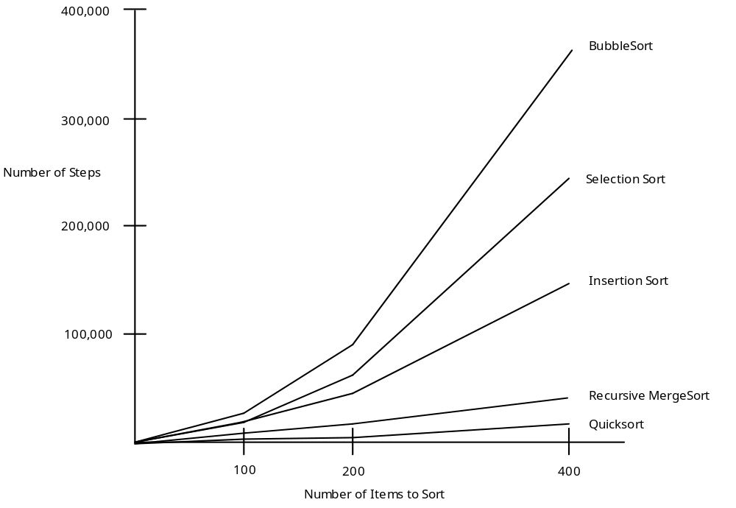

Note: This graph was generated from the Answer Sheet W.A.20.1 - Comparison of Sorting Algorithms.

